# Unit Testing

## Summary

## Test 1: Logging In

**Test Result: Successful**

## Test 2: Registering as a Customer

**Test Result: Successful**

## Test 3: Tracking a Package

**Test Result: Successful**

## Test 4: Get Shipping Rates

**Test Result: Successful**

## Test 5: Booking a Package

**Test Result: Successful**

## Test 6: Logging Out

**Test Result: Successful**

## Test 7: Driver Viewing/Changing Consignment Note/Shipment Information

**Test Result: Successful**

## Logging In

### Correct Login Details

|  |  |
| --- | --- |
| C:\Users\Matthew Magin\Downloads\screencapture-localhost-8080-dashboard-login-php-1477122997298.png | C:\Users\Matthew Magin\OneDrive\University\Year 2 - Semester 2\cab202\topic11\screencapture-localhost-8080-dashboard-login-php-1477123131716.png |
| login.php original state | login.php correct form data (credentials) entered |
| The Expected Result:  After correct form data is entered 🡪 submit button 🡪 page redirects to dashboard.php 🡪 Customer is logged in. | |

#### Output

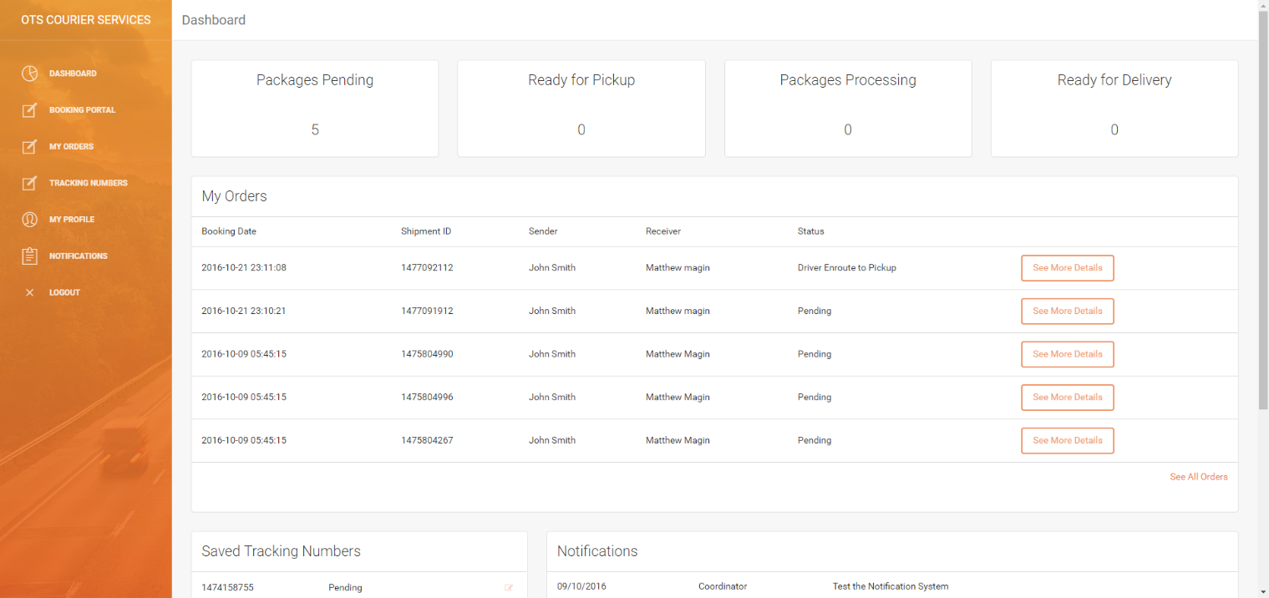

### Incorrect Login Details

|  |  |
| --- | --- |
| C:\Users\Matthew Magin\Downloads\screencapture-localhost-8080-dashboard-login-php-1477122997298.png | C:\Users\Matthew Magin\OneDrive\University\Year 2 - Semester 2\cab202\topic11\screencapture-localhost-8080-dashboard-login-php-1477125808661.png |
| login.php original state | login.php incorrect form data (credentials) entered |
| The Expected Result:  After incorrect form data is entered 🡪 submit button 🡪 page redirects to dashboard.php 🡪 Customer is logged in. | |

#### Output

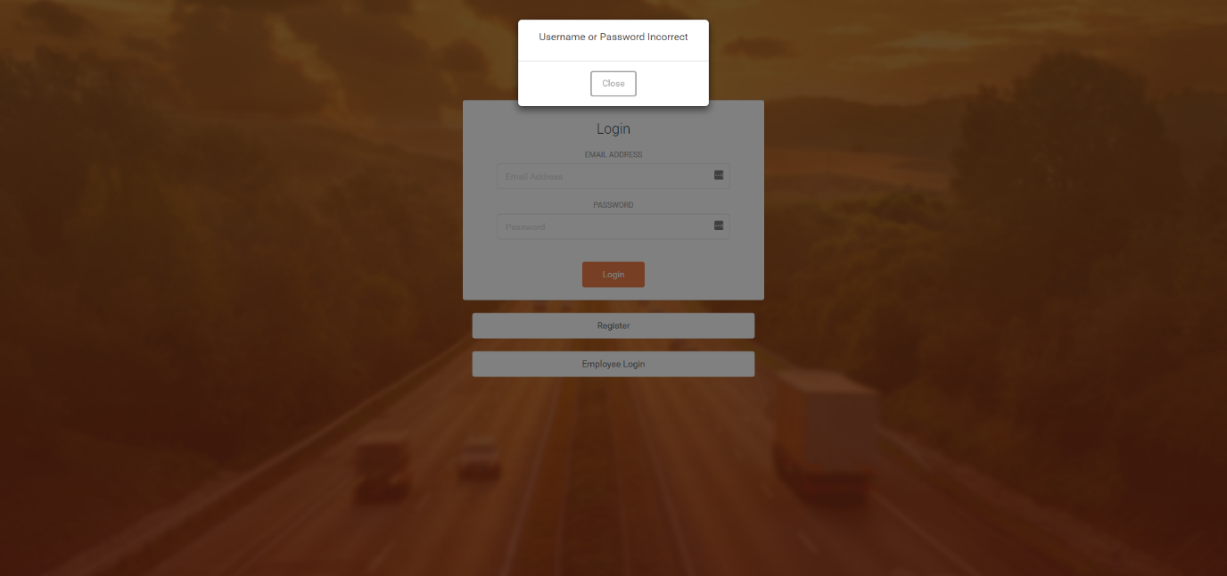

**Test Successful – The test was successful because the user was able to enter their details and login to the account. Additionally, if the user enters incorrect data the user cannot login.**

## Registering as a Customer

|  |  |
| --- | --- |
| C:\Users\Matthew Magin\OneDrive\University\Year 2 - Semester 2\cab202\topic11\screencapture-localhost-8080-dashboard-register-php-1477126151517.png | C:\Users\Matthew Magin\OneDrive\University\Year 2 - Semester 2\cab202\topic11\screencapture-localhost-8080-dashboard-register-php-1477184212273.png |
| register.php original state | register.php correct form data entered |
| The Expected Result:  After customer details are entered 🡪 submit button 🡪 page redirects to login.php 🡪 Customer can then login.  Additionally, the customers details appear in the customers table in the database Output C:\Users\Matthew Magin\OneDrive\University\Year 2 - Semester 2\cab202\topic11\screencapture-localhost-8080-dashboard-login-php-1477184345731.png | |

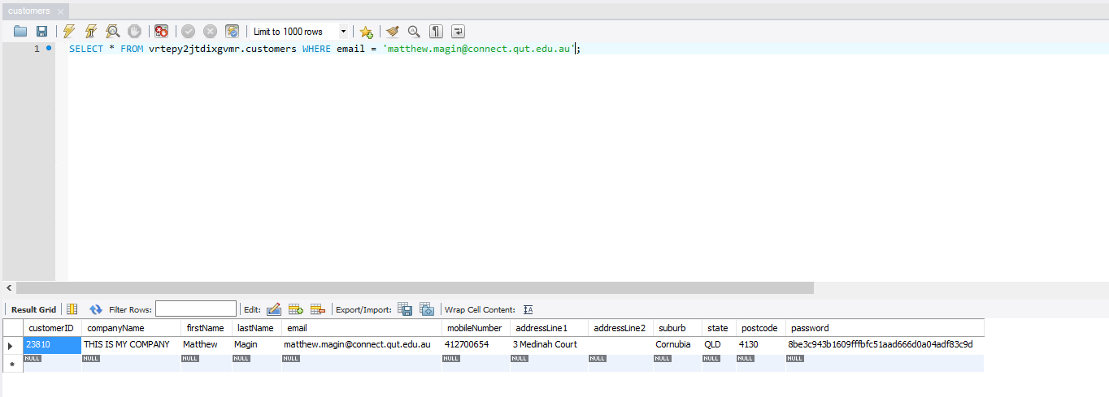

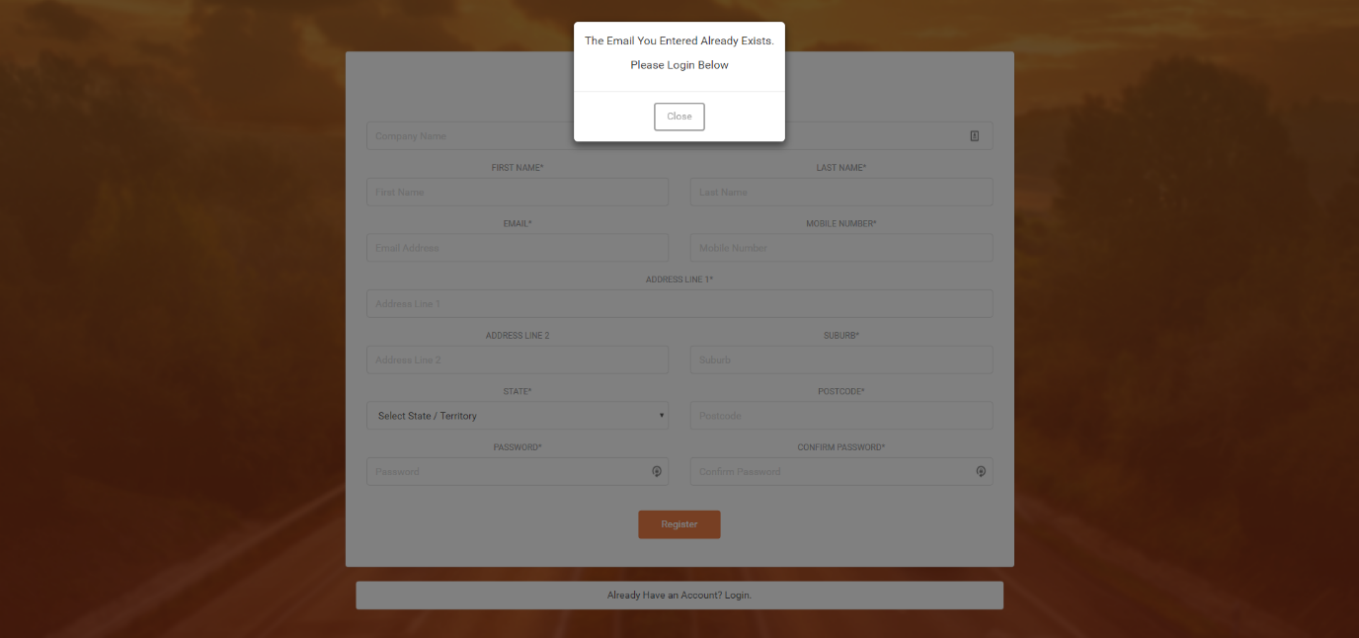

Email inputted: matthew.d.magin@gmail.com (already in the database)

**Test Successful – The test was successful because the user entered their details, click the submit button and they are redirected to the login page. And the customer’s details are saved in the database. If the email is already registered an error message appears.**

## Tracking a Package

### Tracking Number Correct

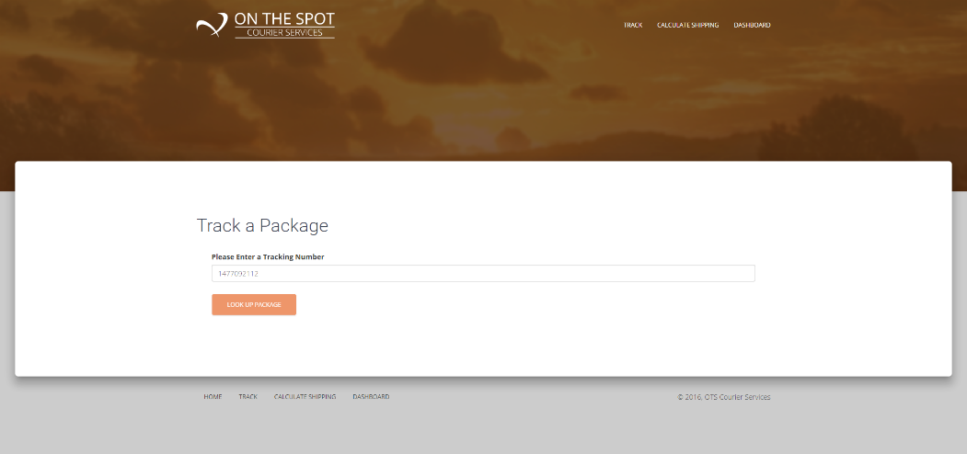

Expected Output: Tracking details are outputted to the screen

#### Output

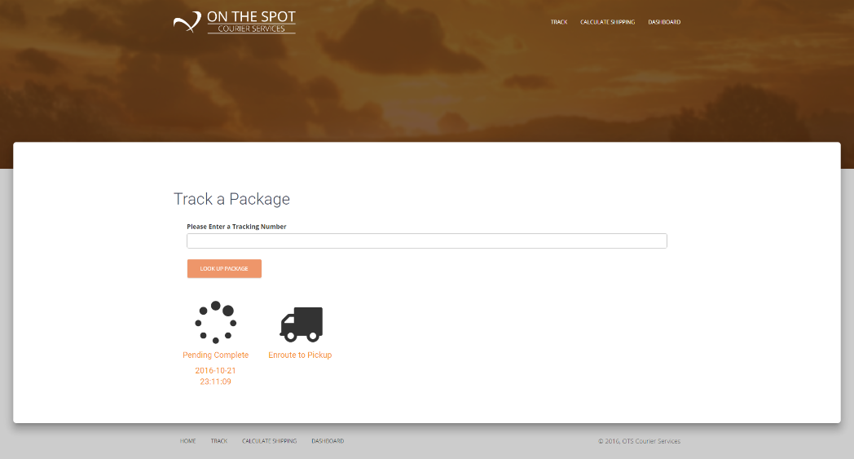

### Tracking Number Not Valid

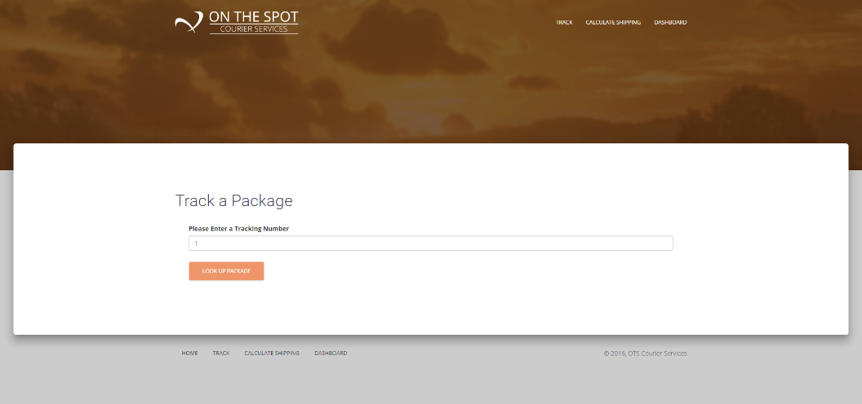

Expected Output: User is notified that the tracking number is not valid

#### Output

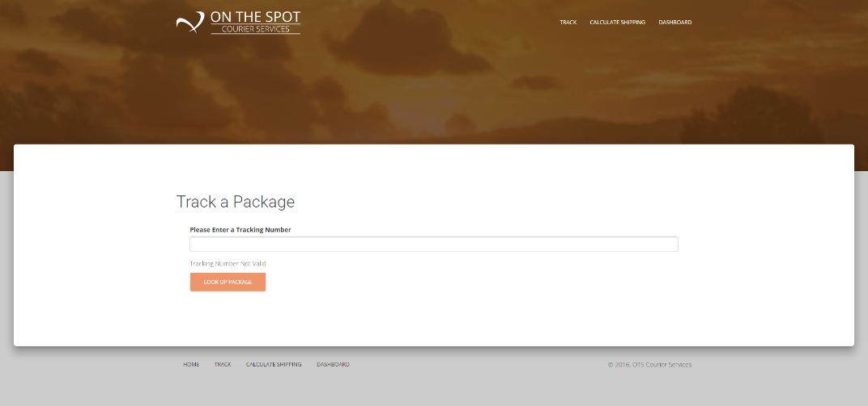

### Tracking Number Does Not Exist

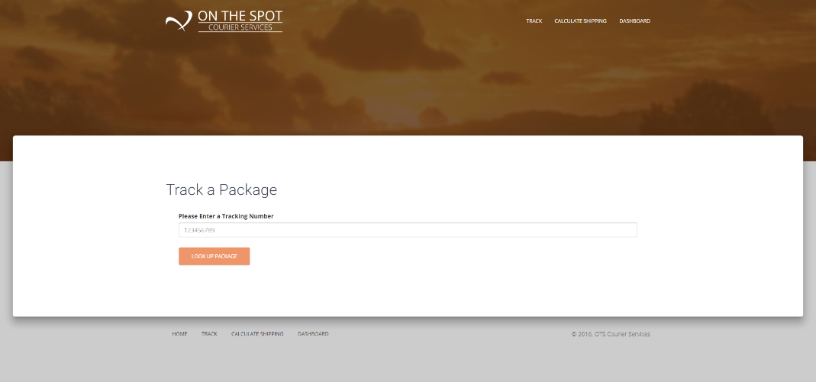

Expected Output: User is notified that the tracking number does not exist

#### Output

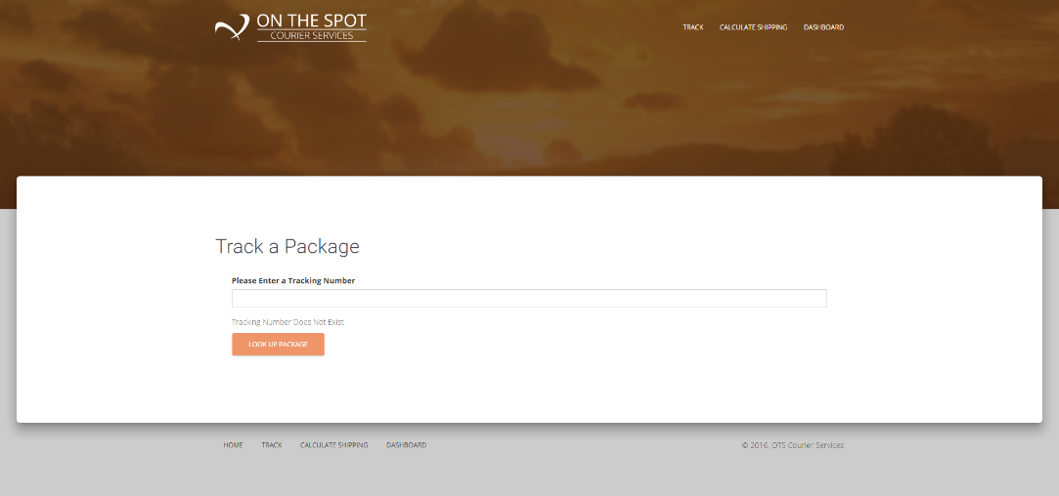

**Test Successful – The test was successful because if the correct tracking details are retrieved and displayed if the tracking number is correct. If the tracking number is not valid / incorrect an error message is displayed.**

## Get Shipping Rates

After inputting the package information in the input boxed the total cost is dynamically updated to the estimated shipping cost.

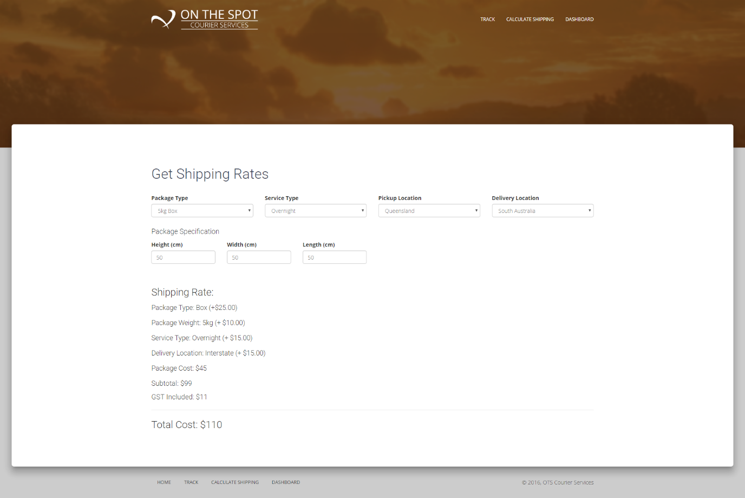

**Test Successful – The test was successful because the total cost was dynamically updated.**

## View Existing Order Details

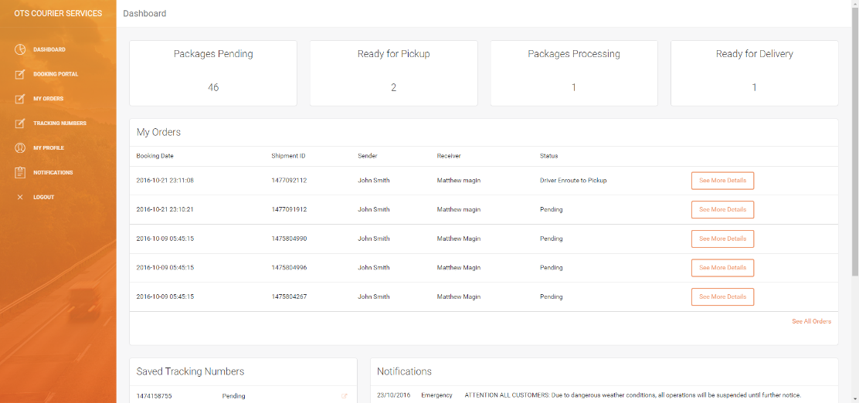

Expected action and result: On-click of the ‘see more details’ button the customer can see all details about the package, print the connote and tax invoice.

#### Output

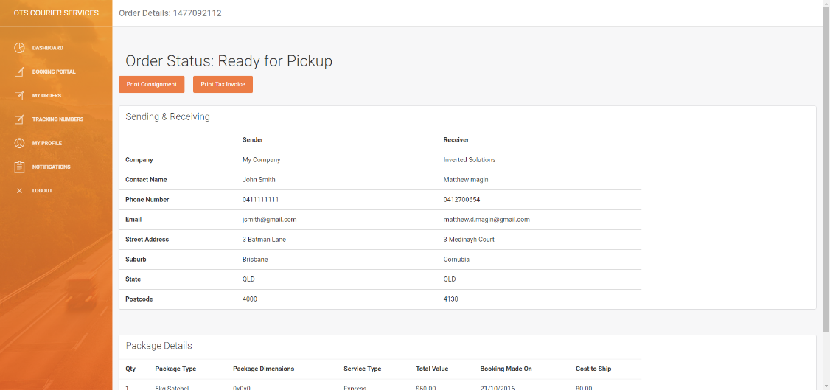

|  |  |
| --- | --- |
| C:\Users\Matthew Magin\OneDrive\University\Year 2 - Semester 2\cab202\topic11\screencapture-localhost-8080-files-taxInvoice-php-1477187752882.png | C:\Users\Matthew Magin\OneDrive\University\Year 2 - Semester 2\cab202\topic11\screencapture-localhost-8080-files-connote-php-1477187736160.png |
| Generated Prefilled Tax Invoice | Generated Prefilled Connote |

**Test Successful – The test was successful because the user was able to view all the order details, quickly see current status and view/print the consignment note and/or tax invoice.**

## Booking a Package

#### Input Data

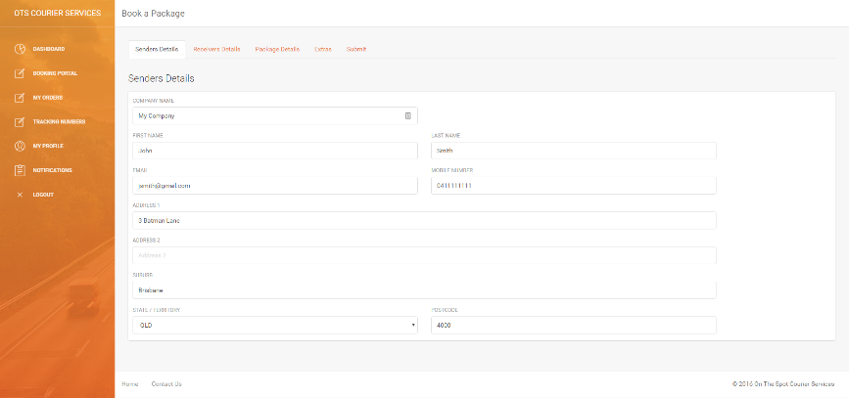

1:Senders Details Automatically Prefilled

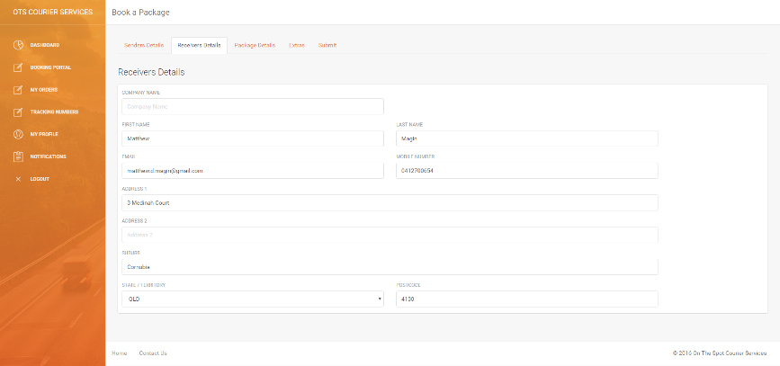

2:Receivers Details

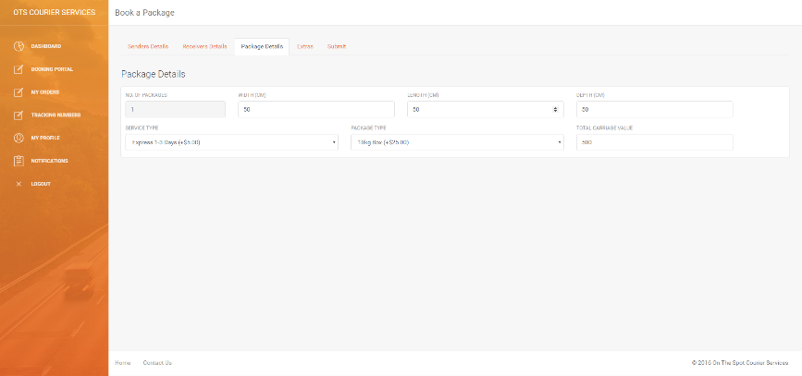

3:Package Details

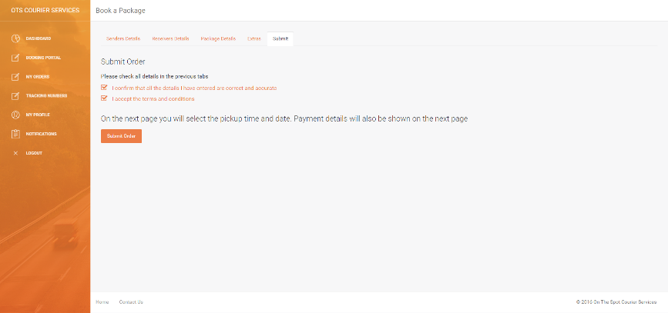

4: Confirmation Page

Expected Action/Result: After selecting the submit order button the user will be redirected to the submitrequestpickup.php page where they can select their payment type, see the payment amount and when the package will be collected.

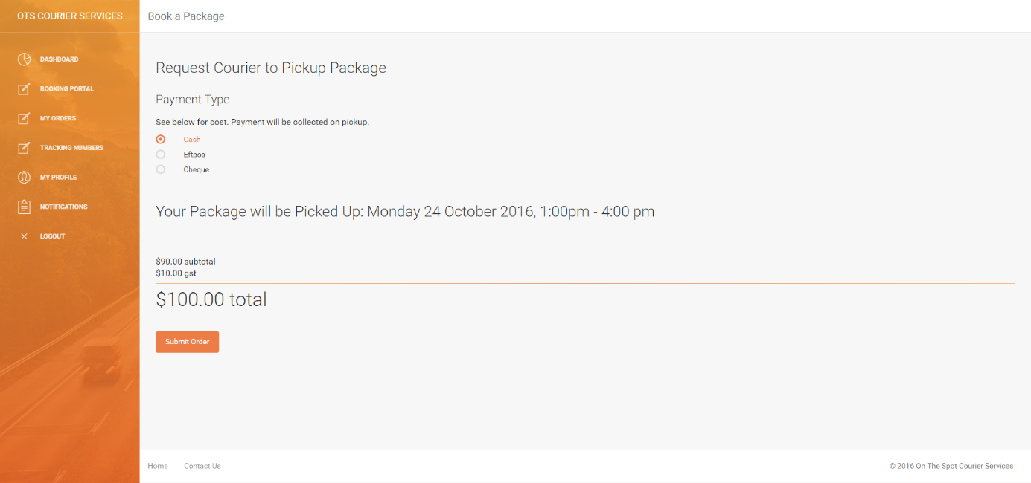

Expected Action/Result: After selecting the submit order button the user will be redirected to the bookingconfirmation.php page where they can see the booking/tracking number, see the full order, print consignment note and tax invoice (see above unit tests for viewing the order/ printing connote and tax invoice).

After returning to the dashboard: the packages pending count increments and the order appears under my orders.

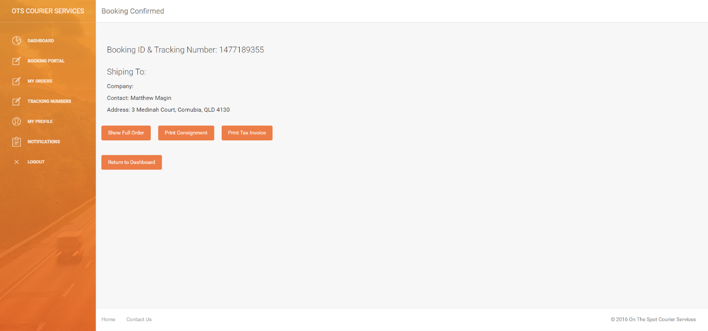

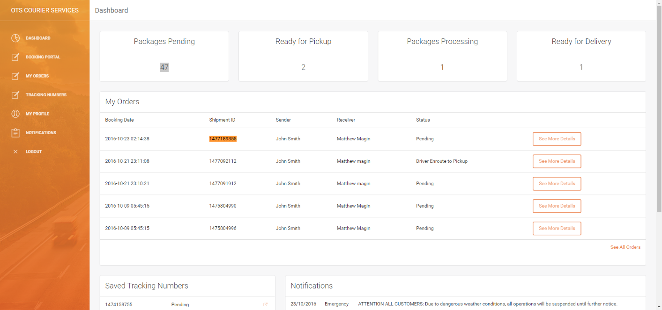

Expected backend output: The order appears in the bookings table, shipments table, payments table, and tracking table.

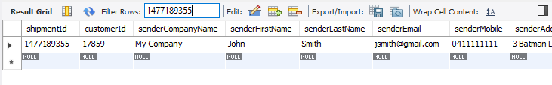

Bookings Table

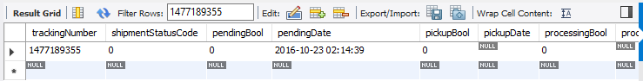

Shipments Table

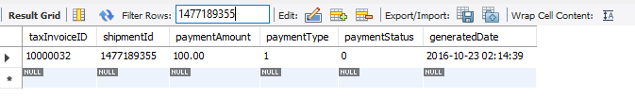

Payments Table

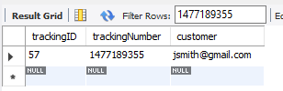  
Tracking Table (for saved tracking numbers)

**Test Successful – The test was successful because the booking was successfully added to the database and the coordinator can assign a driver from the coordinator portal.**

## Logging Out

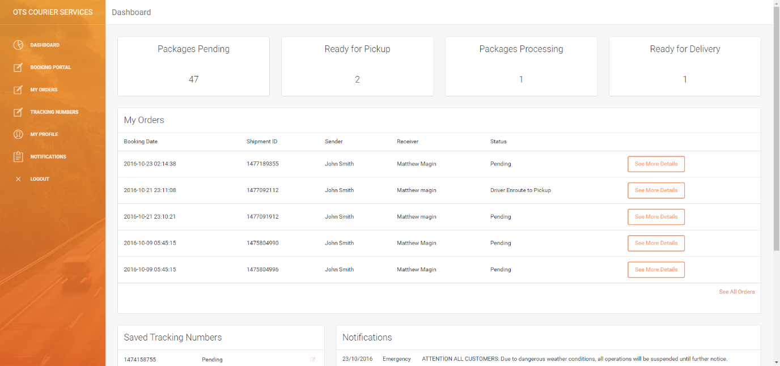

Expected Action/Result: After selected the logout button the user will be redirected to index.php. They will then need to login again the go back to the dashboard.

#### Output

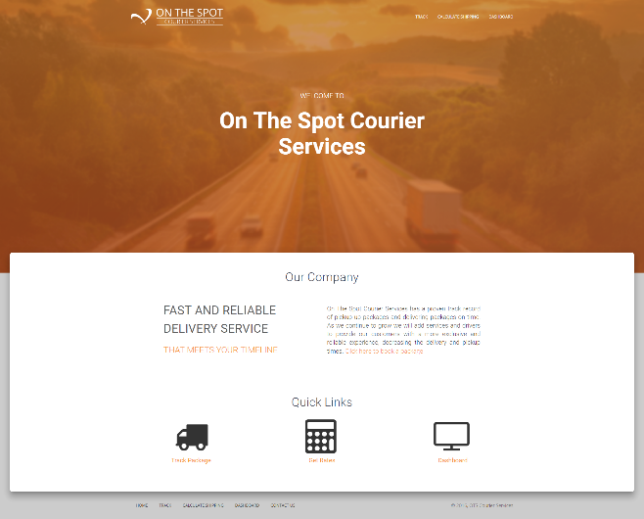



**Test Successful – The test was successful because the user was able to logout.**

## Driver Viewing/Changing Consignment Note/Shipment Information

#### Input Data

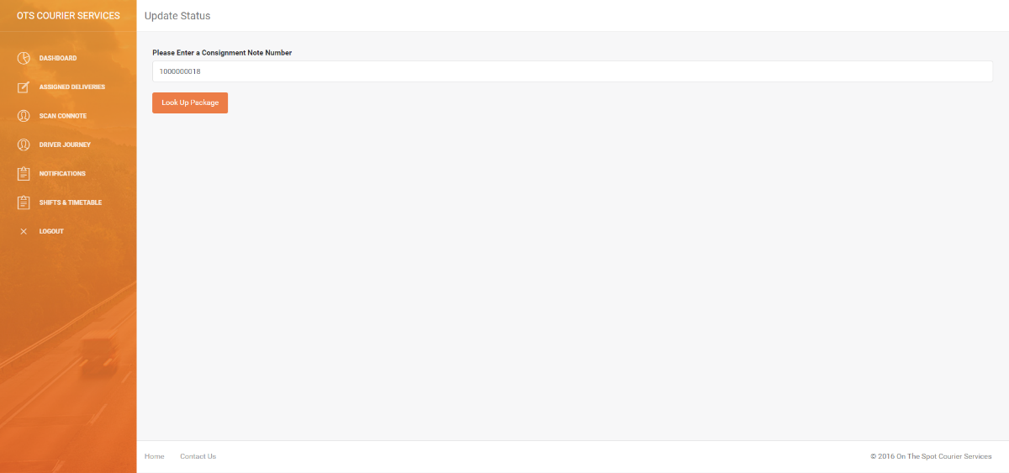

Expected Action/Result: After entering the consignment note number, the order details are pulled up.

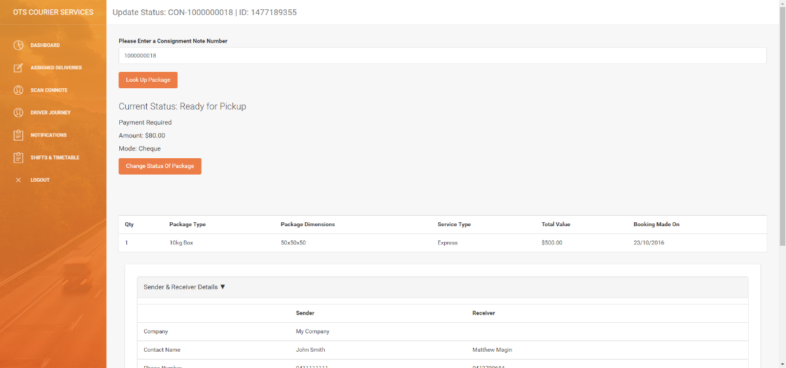

Expected Action/Result: After clicking ‘change status of package’ the driver can select the new status and submit it. Then the new status is reflected when the connote is pulled back up.

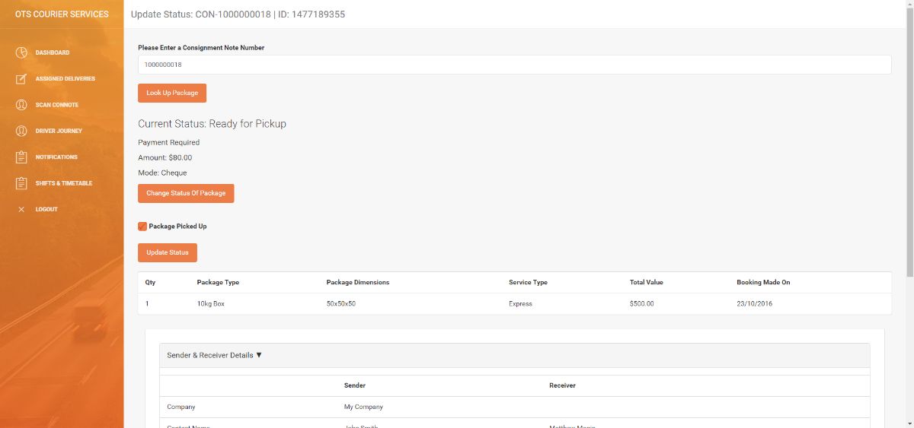

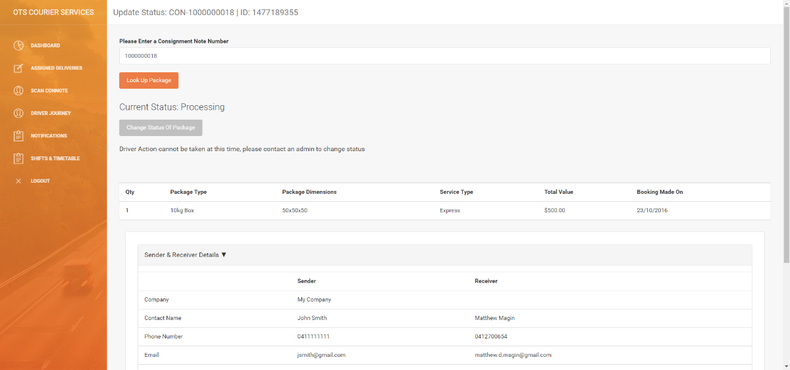

**Test Successful – The test was successful because the driver was able to view the order details and update the status successfully.**